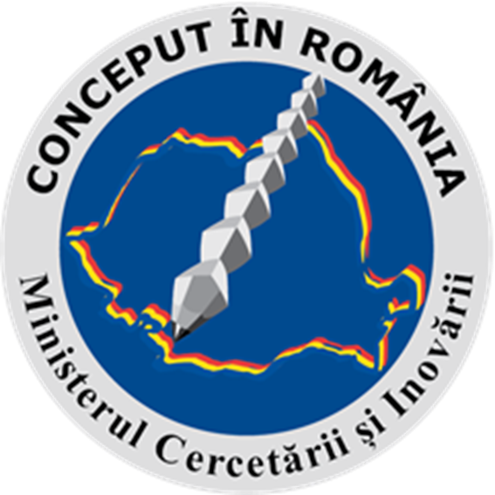

1st International Conference on Emerging Technologies in Materials Engineering EmergeMAT
and
4th International Workshop on Materials under Extreme Conditions SUPERMAT
14-16 November 2018
Bucharest, Romania

REGISTRATION FORM

Name | Organisation | Email | Telephone | Section
*) If applicable, please specify:
oral presentation
poster

DEADLINE  for registration and abstract submission:  October 1st, 2018 | CONTACT  Please forward this registration form to:  Ioana Vlaicu, IMNR  email: ioana.vlaicu@imnr.ro  Phone: (+4021)3522046/ext.131  Fax: (+4021)3522049

